**Project Proposal**

**AI-Powered Meal Planner & Nutrition Tracker**

**1. Introduction:**

A healthy diet needs to be planned for meals as well as nutritional intake tracked. A lack of knowledge on balanced nutrition, dietary preferences, and time constraints is the reason why many people find it hard to plan the meals in their daily regimen. Manually tracking calories and macronutrients is also a lot of work and not very accurate.

Fitness and nutrition apps do exist but they do not necessarily include the interested user's own inputs for meal details which would make the process quite tedious. In fact, such apps may not offer to give suggestions on food based on the user’s personal health goals, preferences, as well as the items they can find at home.

This is a project towards the answering of these challenges which is by the way of an AI Powered Meal Planner & Nutrition Tracker. Users will provide the app with dietary needs, fitness goals and availability of certain ingredients, and the app will suggest customized meal plans accordingly. It will also use integration of food recognition technology and barcode scanning to track daily calorie and macronutrient intake as well.

**2. Problem Statement:**

Meal planning and nutrition tracking are difficult for people for the reasons of lack of personalized suggestions, time constraints and manual logging of food intake. General meal plans from existing apps are less convenient for the user as these apps need to have manual input. This gap impacts unhealthy eating behavior, doesn’t help in achieving dietary goals, and there is lesser consumer knowledge regarding nutrien consumption.

The proposed AI-Powered Meal Planner & Nutrition Tracker will solve this problem by offering:

* AI-driven personalized meal recommendations
* Automatic tracking of food intake through barcode scanning and image recognition
* A real-time nutritional breakdown to help users stay on track with their goals

**3. Project Description:**

The AI-Powered Meal Planner & Nutrition Tracker will enable users to:  
Generate meal plans based on dietary preferences, allergies, and fitness goals  
Scan food items using barcode recognition or food image recognition for automatic tracking  
Receive real-time nutritional insights (calories, protein, fats, carbs, vitamins)  
Log meals manually or from suggested recipes with an easy-to-use interface

Set daily calorie and macronutrient goals and track progress  
Analyze eating habits with weekly and monthly reports

By integrating AI-driven meal recommendations and automated tracking, the app will simplify meal planning and encourage healthier eating habits.

**4. Technologies to be Used:**

We will utilize the following technologies:

* **Frontend:** React Native (to support iOS and Android)
* **Backend:** FastAPI (for API development and real-time updates)
* **Database:** PostgreSQL (to store user preferences, food data, and nutritional logs)
* **AI & Machine Learning:** TensorFlow Lite / PyTorch Mobile (for food recognition and AI-based meal recommendations)
* **Barcode Scanning:** react-native-camera or react-native-barcode-scanner (for quick food logging)
* **Authentication:** JWT tokens (for secure login and session management)

**5. Gantt Chart and Timeline:**

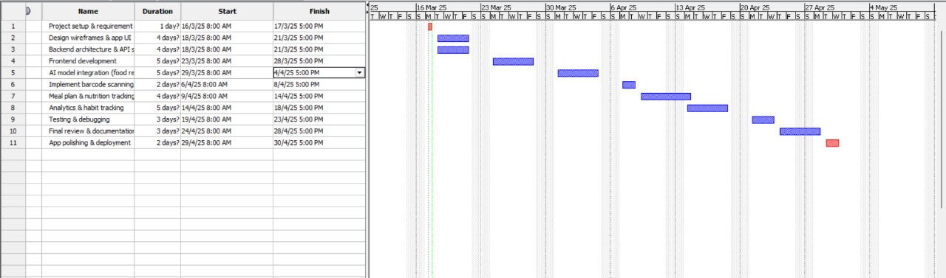

|  |  |  |  |
| --- | --- | --- | --- |
| **Task** | **Start Date** | **End Date** | **Assigned To** |
| Project setup & requirement gathering | Mar 16 | Mar 17 | All Team Members |
| Design wireframes & app UI | Mar 18 | Mar 21 | All Team Members |
| Backend architecture & API setup | Mar 18 | Mar 21 | Sravani & Yashwanth |
| Frontend development | Mar 23 | Mar 28 | Vikas reddy & Ajay ajjuri |
| AI model integration (food recognition) | Mar 29 | Apr 4 | Sravani & Vikas |
| Implement barcode scanning feature | Apr 6 | Apr 8 | Vikas & Ajay |
| Meal plan & nutrition tracking features | Apr 9 | Apr 14 | Sravani & Yashwanth |
| Analytics & habit tracking | Apr 14 | Apr 18 | Sravani & Vikas |
| Testing & debugging | Apr 19 | Apr 23 | All Team Members |
| Final review & documentation | Apr 24 | Apr 28 | All Team Members |
| App polishing & deployment | Apr 29 | Apr 30 | All Team Members |

**6. Conclusion:**

An AI-Powered Meal Planner & Nutrition Tracker will provide a smart solution for everyone who wants to eat healthy but doesn’t want to spend hours writing everything down in a manual food log. The app will combine AI-based meal planning, real time nutrition tracking and eventually, if developed, will be able to be used with barcode scanning to make better food choices effortlessly.

All the application will be built using modern technology like React Native, FastAPI, PostgreSQL, and the AI models to provide a very smooth user experience. It will change how people plan and track their meals with its personalized approach and automation.

**7. Team Members:**

* Sravani Vadathya
* Yashwanth gundubogula
* Vikas reddy
* Ajay ajjuri